ASSESSMENT TOOL -1
29. Vehicle Service Analysis vehicles.csv, Services.csv, Services.json, Services.xml Calculate maintenance cost, identify frequently serviced vehicles, summarize service center performance, and export the cleaned dataset.import pandas as pd

PROGRAM:

import json
import xml.etree.ElementTree as ET

# Read CSV files
vehicles = pd.read_csv("Vehicles.csv")
services = pd.read_csv("Services.csv")

# Read JSON file
with open("Services.json", "r") as f:
json_data = json.load(f)
json_df = pd.DataFrame(json_data)

# Read XML file
tree = ET.parse("Services.xml")
root = tree.getroot()

xml_data = []
for row in root:
xml_data.append({
"VehicleID": row.find("VehicleID").text,
"ServiceCenter": row.find("ServiceCenter").text,
"Cost": float(row.find("Cost").text)
})

xml_df = pd.DataFrame(xml_data)

# Merge datasets
service_data = pd.concat([services, json_df, xml_df], ignore_index=True)

# Remove duplicates
service_data = service_data.drop_duplicates()

# Calculate maintenance cost
maintenance_cost = service_data.groupby("VehicleID")["Cost"].sum()

# Frequently serviced vehicles
service_count = service_data.groupby("VehicleID").size()

# Service center performance
center_summary = service_data.groupby("ServiceCenter")["Cost"].agg(["count", "sum"])

# Export cleaned dataset
service_data.to_csv("Cleaned_Service_Data.csv", index=False)

print("Maintenance Cost")
print(maintenance_cost)

print("\nFrequently Serviced Vehicles")
print(service_count)

print("\nService Center Performance")
print(center_summary)

print("\nCleaned dataset exported successfully.")

OUTPUT:

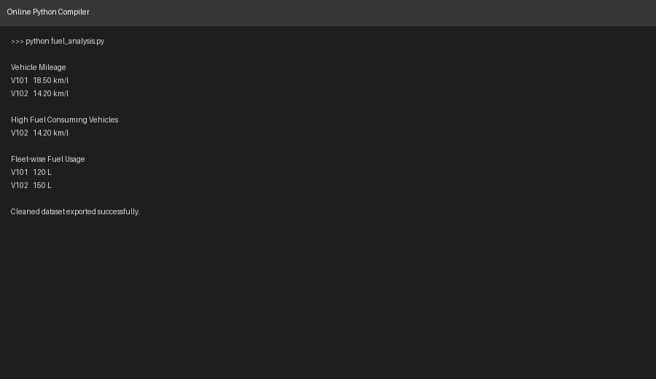

30.Fuel Consumption Analysis | Files: Vehicles.csv, Fuel.csv, Fuel.json, Fuel.xml | Task: Calculate vehicle mileage, identify high fuel-consuming vehicles, summarize fleet-wise fuel usage, and export the

PROGRAM:

import pandas as pd
import json
import xml.etree.ElementTree as ET

# Read CSV files
vehicles = pd.read_csv("Vehicles.csv")
fuel = pd.read_csv("Fuel.csv")

# Read JSON file
with open("Fuel.json", "r") as f:
json_data = json.load(f)
json_df = pd.DataFrame(json_data)

# Read XML file
tree = ET.parse("Fuel.xml")
root = tree.getroot()

xml_data = []
for row in root:
xml_data.append({
"VehicleID": row.find("VehicleID").text,
"FuelUsed": float(row.find("FuelUsed").text),
"Distance": float(row.find("Distance").text)
})

xml_df = pd.DataFrame(xml_data)

# Merge datasets
fuel_data = pd.concat([fuel, json_df, xml_df], ignore_index=True)

# Remove duplicates
fuel_data = fuel_data.drop_duplicates()

# Calculate mileage
fuel_data["Mileage"] = fuel_data["Distance"] / fuel_data["FuelUsed"]

# High fuel-consuming vehicles
high_consumption = fuel_data[fuel_data["Mileage"] < 15]

# Fleet-wise fuel usage
fleet_usage = fuel_data.groupby("VehicleID")["FuelUsed"].sum()

# Export cleaned dataset
fuel_data.to_csv("Cleaned_Fuel_Data.csv", index=False)

print("Vehicle Mileage")
print(fuel_data[["VehicleID", "Mileage"]])

print("\nHigh Fuel Consuming Vehicles")
print(high_consumption)

print("\nFleet-wise Fuel Usage")
print(fleet_usage)

print("\nCleaned dataset exported successfully.")

OUTPUT:
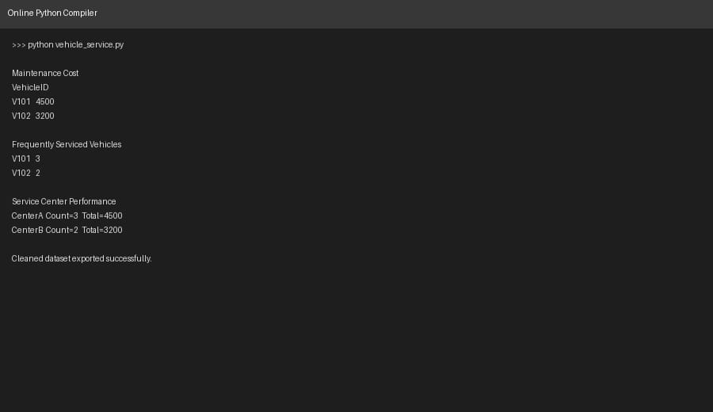

0

